**DAILY ONLINE ACTIVITIES SUMMARY**

|  |  |  |  |  |  |  |  |
| --- | --- | --- | --- | --- | --- | --- | --- |
| **Date:** | **23May 2020** | | | | **Name:** | **K.ISHA HEGDE** | |
| **Sem & Sec** | **4th sem A** | | | | **USN:** | **4al18cs031** | |
| **Online Test Summary** | | | | | | | |
| **Subject** | | **Data communication** | | | | | |
| **Max. Marks** | | **30** | | **Score** | | **28** | |
| **Certification Course Summary** | | | | | | | |
| **Course** | **Digital security awareness** | | | | | | |
| **Certificate Provider** | | | **ALISON** | **Duration** | | | **2hrs** |
| **Coding Challenges** | | | | | | | |
| **Problem Statement:** 1. **Write a C Program to generate first N Triangular Numbers (Where N is Read from the Key board).** | | | | | | | |
| **Status: executed** | | | | | | | |
| **Uploaded the report in Github** | | | | **Yes** | | | |
| **If yes Repository name** | | | | **[http://github.com/iishaii/locked-down_coding](http://github.com/iishaii/locked-down_coding" \o "http://github.com/iishaii/locked-down_coding)** | | | |
| **Uploaded the report in slack** | | | | **Yes** | | | |

Online Test Details: (Attach the snapshot and briefly write the report for the same)

Certification Course Details: (Attach the snapshot and briefly write the report for the same)

Coding Challenges Details: (Attach the snapshot and briefly write the report for the same)

**Online Test Summary:**

Today **DATA COMMUNICATION (18cs46)** was conducted of first module. Total marks for the test was 30.

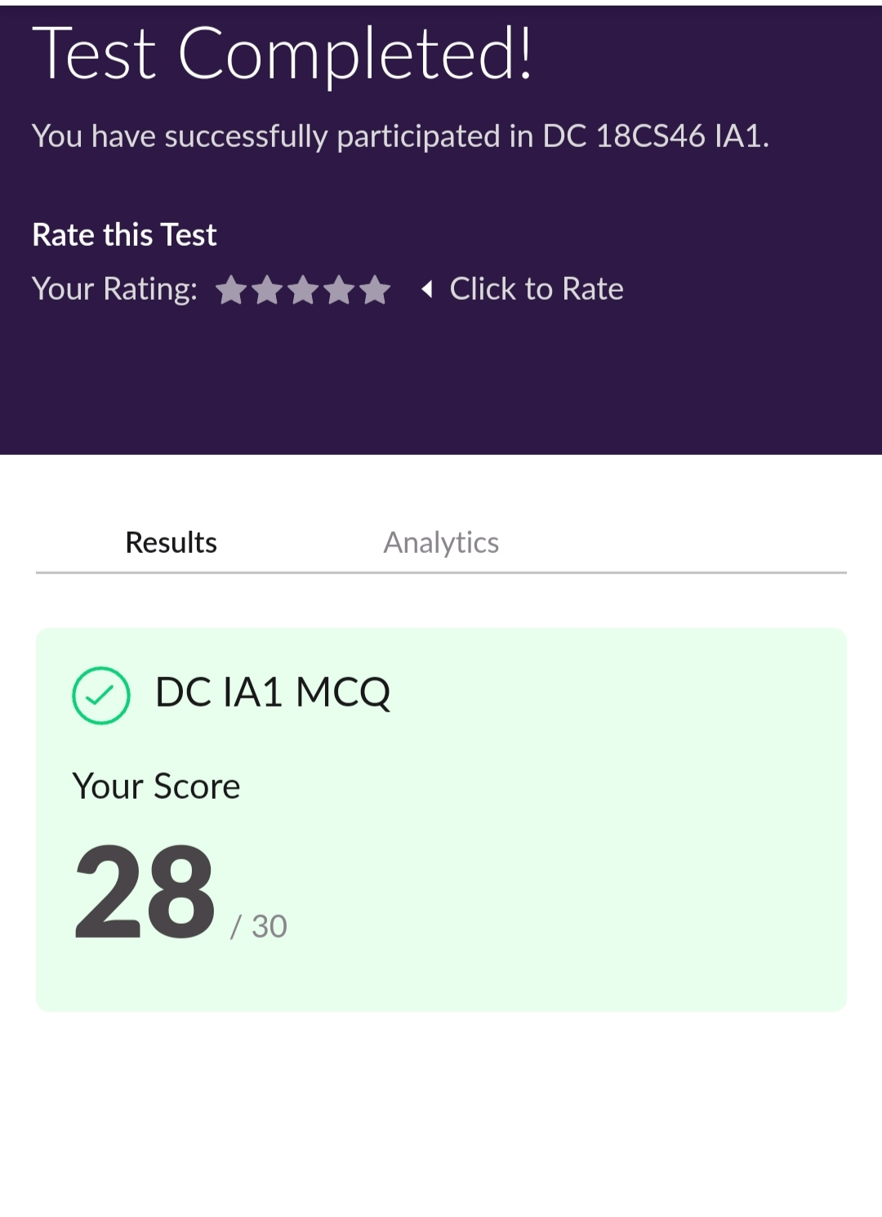

**Certification Course Summary: As a continuation of DIGITAL SECURITY AWARENESS , I completed module 6,7,8,9. After each module I had to take up assessments and scored 90%.**

**Mod 6:This module covers why backups should be done, what types of backups can be done, what data should be backed up, where backups should be stored, how to perform backups, backup utilities, backup management practices, passwords, password management, and password policies.**

**Mod 7:This module will also cover distributed denial of service attacks (DDoS). This module will also cover ways in which you can get infected with malware and how to avoid it.**

**Mod 8:About physical security such as business and home security as well as home and workstation security, such as locking the desktop and cleaning away private papers. This module will also cover encryption as the ultimate protection from theft .**

**Mod 9:Learn what intellectual property is as well as what software piracy is. This module will cover reading the end-user license agreement (EULA) to see what permissions are given for proper legal use of the software.**



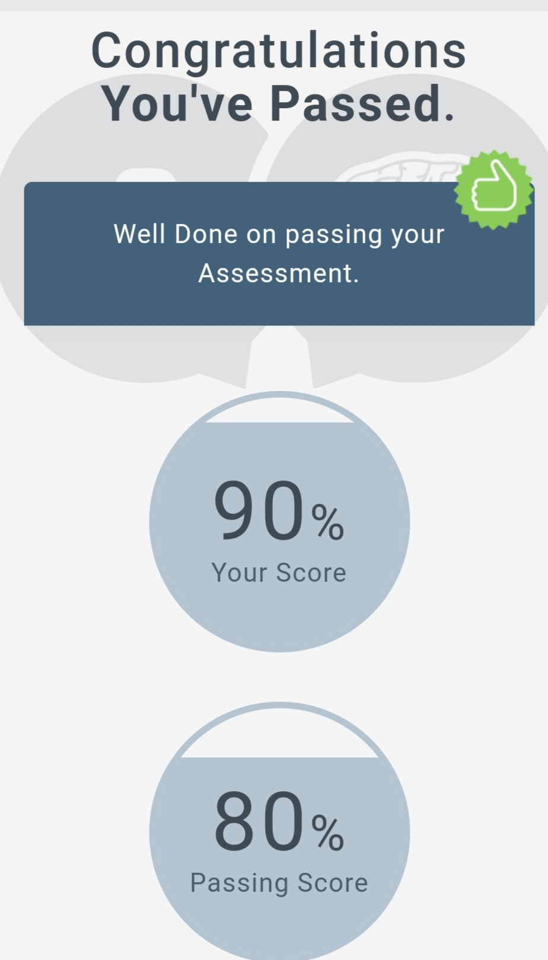

**Coding Challenges:**

Today I solved 1 coding challenge:

1. **Write a C Program to generate first N Triangular Numbers (Where N is Read from the Key board).**

